**29. Retrieve weather data for Houston on 8/8/2022 with temperature descriptions and heat index :**

SELECT City_Name, D_Date, Temperature,

CASE

WHEN Temperature >= 90 THEN 'Hot'

WHEN Temperature >= 80 THEN 'Warm'

WHEN Temperature >= 60 THEN 'Mild'

WHEN Temperature >= 40 THEN 'Cool'

ELSE 'Cold'

END AS Temperature_Description,

-- Calculate Heat Index

0.5 * (Temperature + 61.0 + (Temperature - 68.0) * 1.2 + Humidity * 0.094) AS Feels_Like,

CONCAT(Precipitation, ' inches') AS Precipitation,

CONCAT(Humidity, '%') AS Humidity,

CONCAT(Wind_Speed, ' mph') AS Wind_Speed,

CONCAT(Daylight_Hours, ' hours') AS Daylight_Hours

FROM weatherdatabase.`texas daily weather data 2022`

WHERE City_Name = 'Houston' AND D_Date = '8/8/2022';



**30. Get the average temperature, precipitation, humidity, wind speed, and daylight hours for Dallas with descriptions**

SELECT City_Name,

AVG(Temperature) AS avg_temperature,

CASE

WHEN AVG(Temperature) >= 90 THEN 'Hot'

WHEN AVG(Temperature) >= 80 THEN 'Warm'

WHEN AVG(Temperature) >= 60 THEN 'Mild'

WHEN AVG(Temperature) >= 40 THEN 'Cool'

ELSE 'Cold'

END AS description_avg_temperature,

AVG(Precipitation) AS avg_precipitation,

CASE

WHEN AVG(Precipitation) >= 0.5 THEN 'Wet'

WHEN AVG(Precipitation) >= 0.1 THEN 'Drizzly'

ELSE 'Dry'

END AS avg_precipitation_description,

AVG(Humidity) AS avg_humidity,

CASE

WHEN AVG(Humidity) >= 80 THEN 'High'

WHEN AVG(Humidity) >= 60 THEN 'Moderate'

ELSE 'Low'

END AS avg_humidity_description,

AVG(Wind_Speed) AS avg_wind_speed,

CASE

WHEN AVG(Wind_Speed) >= 10 THEN 'Windy'

WHEN AVG(Wind_Speed) >= 5 THEN 'Breezy'

ELSE 'Calm'

END AS avg_wind_speed_description,

AVG(Daylight_Hours) AS avg_daylight_hours,

CASE

WHEN AVG(Daylight_Hours) >= 12 THEN 'Long'

WHEN AVG(Daylight_Hours) >= 10 THEN 'Average'

ELSE 'Short'

END AS avg_daylight_hours_description

FROM weatherdatabase.`texas daily weather data 2022`

WHERE City_Name = 'Dallas'

GROUP BY City_Name;



31. Find the days with the highest precipitation for each city with descriptions:

SELECT City_Name,

D_Date,

Precipitation,

CASE

WHEN Precipitation >= 2.0 THEN 'Heavy Rain'

WHEN Precipitation >= 1.0 THEN 'Moderate Rain'

WHEN Precipitation >= 0.1 THEN 'Light Rain'

ELSE 'No Significant Rain'

END AS Precipitation_Description

FROM (

SELECT City_Name, D_Date, Precipitation,

ROW_NUMBER() OVER (PARTITION BY City_Name ORDER BY Precipitation DESC) AS RowNum

FROM weatherdatabase.`texas daily weather data 2022`

WHERE City_Name IN ('Austin', 'Dallas', 'Houston', 'San Antonio', 'Pecos', 'El Paso', 'Midland')

) Ranked

WHERE RowNum = 1;

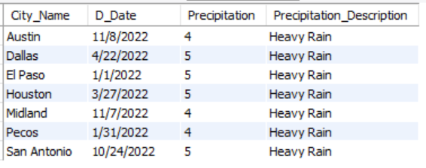

**32. Calculate the total precipitation for each city in January with descriptions**

SELECT City_Name,

SUM(Precipitation) AS Total_Precipitation,

CASE

WHEN SUM(Precipitation) >= 25 THEN 'Heavy Rainfall'

WHEN SUM(Precipitation) >= 15 THEN 'Moderate Rainfall'

WHEN SUM(Precipitation) >= 5 THEN 'Light Rainfall'

ELSE 'Very Low Precipitation'

END AS Precipitation_Description

FROM weatherdatabase.`texas daily weather data 2022`

WHERE City_Name IN ('Austin', 'Dallas', 'Houston', 'San Antonio', 'Pecos', 'El Paso', 'Midland')

AND D_Date like "%/1/%"

GROUP BY City_Name;

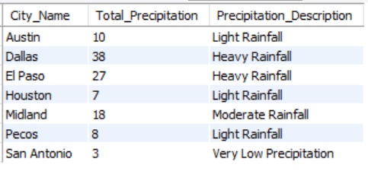

# 33. Retrieve the date and temperature for the coldest day in each city with descriptions with heat index:

WITH ColdestDays AS (

SELECT City_Name, D_Date, Temperature, Humidity,

ROW_NUMBER() OVER (PARTITION BY City_Name ORDER BY Temperature ASC) AS RowNum

FROM weatherdatabase.`texas daily weather data 2022`

)

SELECT CD.City_Name, CD.D_Date, CD.Temperature,

0.5 * (Temperature + 61.0 + (Temperature - 68.0) * 1.2 + Humidity * 0.094) AS Feels_Like,

CASE

WHEN CD.Temperature >= 90 THEN 'Hot'

WHEN CD.Temperature >= 80 THEN 'Warm'

WHEN CD.Temperature >= 60 THEN 'Mild'

WHEN CD.Temperature >= 40 THEN 'Cool'

ELSE 'Cold'

END AS Temperature_Description

FROM ColdestDays CD

WHERE RowNum = 1;

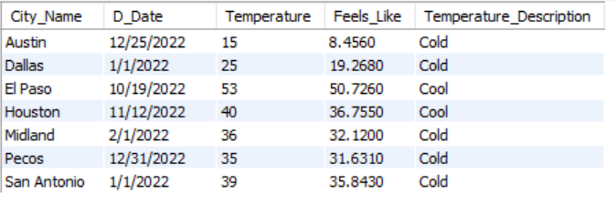

**# 34. Find the average humidity and wind speed for each city in March with descriptions**

SELECT City_Name,

AVG(Humidity) AS Avg_Humidity,

CASE

WHEN AVG(Humidity) >= 70 THEN 'High Humidity'

WHEN AVG(Humidity) >= 50 THEN 'Moderate Humidity'

ELSE 'Low Humidity'

END AS Humidity_Description,

AVG(Wind_Speed) AS Avg_Wind_Speed,

CASE

WHEN AVG(Wind_Speed) >= 10 THEN 'Windy'

WHEN AVG(Wind_Speed) >= 5 THEN 'Breezy'

ELSE 'Calm'

END AS Wind_Speed_Description

FROM weatherdatabase.`texas daily weather data 2022`

WHERE MONTH(STR_TO_DATE(D_Date, '%m/%d/%Y')) = 3

GROUP BY City_Name;

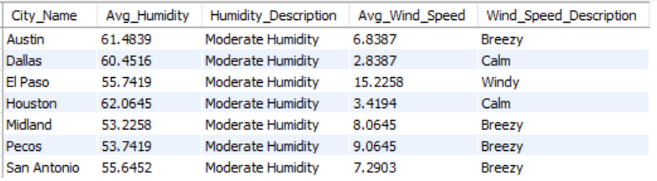

**# 35. Retrieve the date and daylight hours for the day with the longest daylight in each city with descriptions**

WITH LongestDaylightDays AS (

SELECT City_Name, D_Date, Daylight_Hours,

ROW_NUMBER() OVER (PARTITION BY City_Name ORDER BY Daylight_Hours DESC) AS RowNum

FROM weatherdatabase.`texas daily weather data 2022`

)

SELECT LDD.City_Name, LDD.D_Date, LDD.Daylight_Hours,

CASE

WHEN LDD.Daylight_Hours >= 12 THEN 'Long Daylight'

WHEN LDD.Daylight_Hours >= 10 THEN 'Average Daylight'

ELSE 'Short Daylight'

END AS Daylight_Description

FROM LongestDaylightDays LDD

WHERE RowNum = 1;

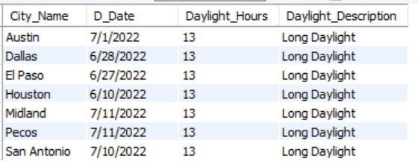

**# 36. Get the maximum temperature recorded for each city with descriptions:**

SELECT City_Name,

MAX(Temperature) AS Max_Temperature,

round(0.5 * (MAX(Temperature) + 61.0 + (MAX(Temperature) - 68.0) * 1.2 + AVG(Humidity) * 0.094), 0) AS Feels_Like,

CASE

WHEN MAX(Temperature) >= 90 THEN 'Hot'

WHEN MAX(Temperature) >= 80 THEN 'Warm'

WHEN MAX(Temperature) >= 60 THEN 'Mild'

WHEN MAX(Temperature) >= 40 THEN 'Cool'

ELSE 'Cold'

END AS Temperature_Description

FROM weatherdatabase.`texas daily weather data 2022`

GROUP BY City_Name;

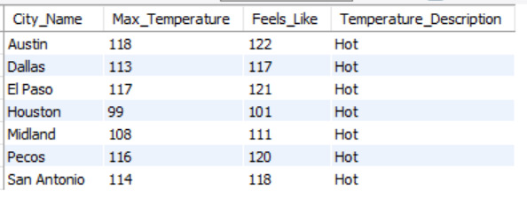

**37. Find the cities where the temperature exceeded 110 degrees Fahrenheit on a specific date with descriptions**

SELECT City_Name,

D_Date,

Temperature,

round(0.5 * (Temperature + 61.0 + (Temperature - 68.0) * 1.2 + Humidity * 0.094), 0) AS Feels_Like,

CASE

WHEN Temperature >= 90 THEN 'Hot'

WHEN Temperature >= 80 THEN 'Warm'

WHEN Temperature >= 60 THEN 'Mild'

WHEN Temperature >= 40 THEN 'Cool'

ELSE 'Cold'

END AS Temperature_Description

FROM weatherdatabase.`texas daily weather data 2022`

WHERE Temperature > 110

order by Temperature desc;

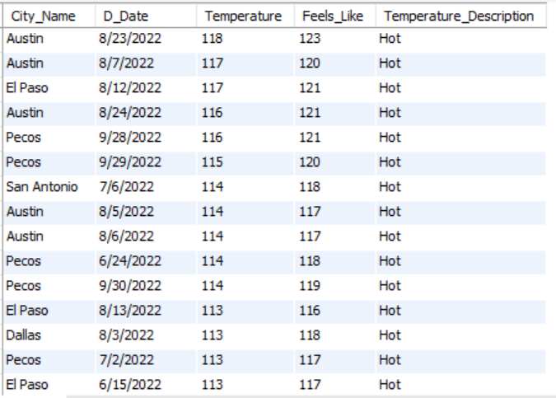

**38 . Retrieve the date and precipitation for days with significant rainfall (more than 4 inches) for Houston with descriptions:**

SELECT D_Date,

Precipitation,

CASE

WHEN Precipitation > 4 THEN 'Significant Rainfall'

ELSE 'No Significant Rainfall'

END AS Precipitation_Description

FROM weatherdatabase.`texas daily weather data 2022`

WHERE City_Name = 'Houston' AND Precipitation > 4;

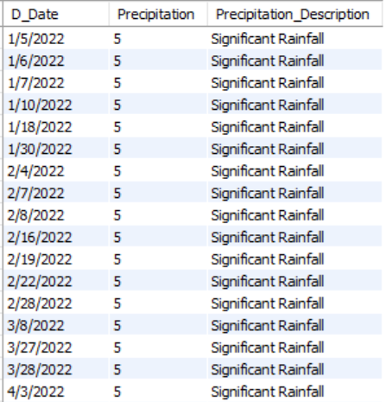

**39. Get the average temperature and humidity for each city on weekdays with descriptions:**

SELECT City_Name,

AVG(Temperature) AS Avg_Temperature,

CAST(AVG(0.5 * (Temperature + 61.0 + (Temperature - 68.0) * 1.2 + Humidity * 0.094)) AS DECIMAL(10,0)) AS Feels_Like,

CASE

WHEN AVG(Temperature) >= 90 THEN 'Hot'

WHEN AVG(Temperature) >= 80 THEN 'Warm'

WHEN AVG(Temperature) >= 60 THEN 'Mild'

WHEN AVG(Temperature) >= 40 THEN 'Cool'

ELSE 'Cold'

END AS Avg_Temperature_Description,

avg(Humidity) as Avg_Humidity,

CASE

WHEN AVG(Humidity) >= 80 THEN 'High'

WHEN AVG(Humidity) >= 60 THEN 'Moderate'

ELSE 'Low'

END AS Avg_Humidity_Description

FROM weatherdatabase.`texas daily weather data 2022`

WHERE WEEKDAY(STR_TO_DATE(D_Date, '%m/%d/%Y')) BETWEEN 0 AND 4 -- Weekdays (Monday to Friday)

GROUP BY City_Name;

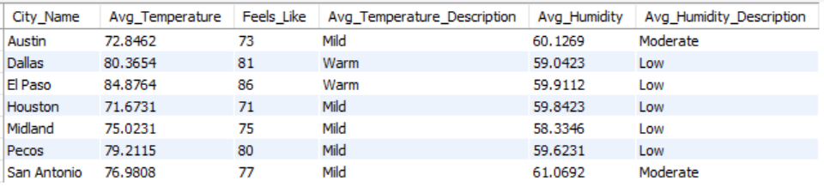

**40. Retrieve the date and wind speed for the windiest day in each city with descriptions:**

WITH WindiestDays AS (

SELECT City_Name, D_Date, Wind_Speed,

ROW_NUMBER() OVER (PARTITION BY City_Name ORDER BY Wind_Speed DESC) AS RowNum

FROM weatherdatabase.`texas daily weather data 2022`

)

SELECT WD.City_Name, WD.D_Date, WD.Wind_Speed,

CASE

WHEN WD.Wind_Speed >= 15 THEN 'Very Windy'

WHEN WD.Wind_Speed >= 10 THEN 'Windy'

WHEN WD.Wind_Speed >= 5 THEN 'Breezy'

ELSE 'Calm'

END AS Wind_Speed_Description

FROM WindiestDays WD

WHERE RowNum = 1;

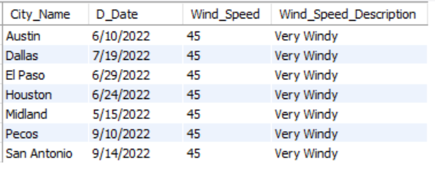

**41. Find the cities where it rained on consecutive days (at least two days in a row) with descriptions**:

WITH RainData AS (

SELECT City_Name, D_Date, Precipitation,

LAG(Precipitation, 1) OVER (PARTITION BY City_Name ORDER BY D_Date) AS PrevDayPrecipitation

FROM weatherdatabase.`texas daily weather data 2022`

)

SELECT RD.City_Name,

SUM(RD.Precipitation) AS Total_Rain,

COUNT(*) AS Consecutive_Days

FROM RainData RD

WHERE RD.Precipitation > 0

GROUP BY RD.City_Name

HAVING MAX(CASE WHEN RD.Precipitation > 0 AND RD.PrevDayPrecipitation > 0 THEN 1 ELSE 0 END) = 1;

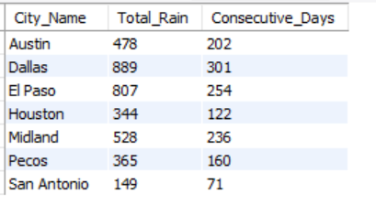

**42. Get the date and daylight hours for the shortest day in each city with descriptions:**

WITH DaylightData AS (

SELECT City_Name, D_Date, Daylight_Hours,

RANK() OVER (PARTITION BY City_Name ORDER BY Daylight_Hours ASC) AS RankShortestDay

FROM weatherdatabase.`texas daily weather data 2022`

)

SELECT DD.City_Name, DD.D_Date, DD.Daylight_Hours,

CASE

WHEN DD.RankShortestDay = 1 THEN 'Shortest Day'

END AS Daylight_Description

FROM DaylightData DD

WHERE DD.RankShortestDay = 1;

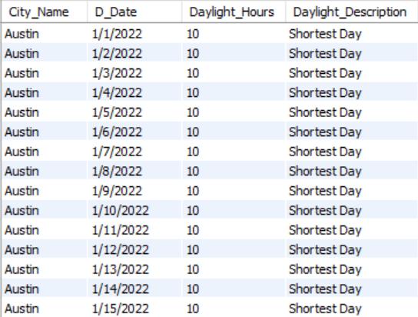

**43. Retrieve the date and temperature for days when the temperature increased by more than 10 degrees Fahrenheit compared to the previous day in San Antonio city with descriptions**

WITH TemperatureData AS (

SELECT City_Name, D_Date, Temperature,

LAG(Temperature, 1) OVER (PARTITION BY City_Name ORDER BY D_Date) AS PrevDayTemperature

FROM weatherdatabase.`texas daily weather data 2022`

WHERE City_Name = 'San Antonio'

)

SELECT TD.City_Name, TD.D_Date, TD.Temperature,

CASE

WHEN TD.Temperature - TD.PrevDayTemperature > 10 THEN 'Temperature Increased by More Than 10°F'

END AS Temperature_Description

FROM TemperatureData TD

WHERE TD.Temperature - TD.PrevDayTemperature > 10;

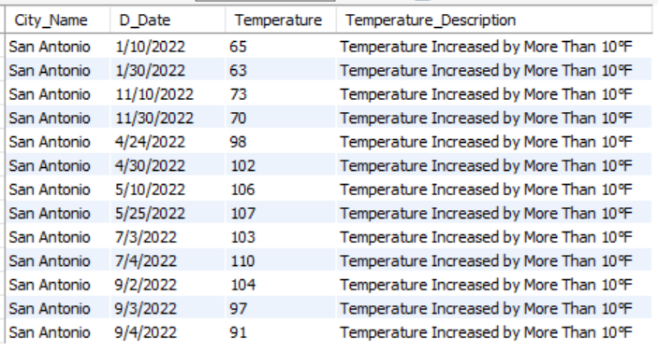

**44. Find the cities where the temperature was within 5 degrees Fahrenheit of the average temperature for the entire dataset on a 2/18/2022 with descriptions**:

WITH AvgTemp AS (

SELECT AVG(Temperature) AS Average_Temperature

FROM weatherdatabase.`texas daily weather data 2022`

),

TemperatureData AS (

SELECT City_Name, D_Date, Temperature,

(SELECT Average_Temperature FROM AvgTemp) AS Average_Temperature,

CASE

WHEN Temperature >= (SELECT Average_Temperature FROM AvgTemp) - 5

AND Temperature <= (SELECT Average_Temperature FROM AvgTemp) + 5 THEN 'Within 5°F of Average'

END AS Temperature_Description

FROM weatherdatabase.`texas daily weather data 2022`

WHERE D_Date = '2/18/2022'

)

SELECT TD.City_Name, TD.Temperature, TD.Average_Temperature, TD.Temperature_Description

FROM TemperatureData TD

WHERE TD.Temperature_Description IS NOT NULL;



**45. Calculate the average temperature for each city, considering only days when it rained with descriptions:**

WITH RainData AS (

SELECT City_Name, D_Date, Temperature, Humidity, Precipitation

FROM weatherdatabase.`texas daily weather data 2022`

WHERE Precipitation > 0

),

AvgTempData AS (

SELECT City_Name, AVG(Temperature) AS Avg_Temperature,

AVG(0.5 * (Temperature + 61.0 + (Temperature - 68.0) * 1.2 + Humidity * 0.094)) AS Feels_Like,

SUM(Precipitation) AS Total_Rain

FROM RainData

GROUP BY City_Name

)

SELECT RD.City_Name, RD.D_Date, RD.Precipitation, AD.Avg_Temperature, AD.Feels_Like, AD.Total_Rain,

CASE

WHEN AD.Avg_Temperature >= 90 THEN 'Hot'

WHEN AD.Avg_Temperature >= 80 THEN 'Warm'

WHEN AD.Avg_Temperature >= 60 THEN 'Mild'

WHEN AD.Avg_Temperature >= 40 THEN 'Cool'

ELSE 'Cold'

END AS Temperature_Description

FROM AvgTempData AD

JOIN RainData RD ON AD.City_Name = RD.City_Name;

